* HTML file has .html extension
* PHP file has a .php extension
* Mixture of HTML and PHP has extension .phtml

**FOUR OPTIONS**

**<?php**

**echo '<h3> Message</h3>';**

**echo '<hr/>';**

**?>**

**<?**

**echo '<h3> Message</h3>';**

**echo '<hr/>';**

**?>**

**<%**

**echo '<h3> Message</h3>';**

**echo '<hr/>';**

**%>**

**<script language=”php”>**

**echo '<h3> Message not XHTML/XML compliant</h3>';**

**</script>**

To configure which tags in php.ini in this case asp_tags is off

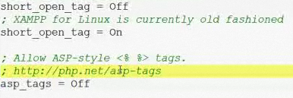

**COMMENTS**

* Single line // #
* Multi lines /* */

Eight types of data

* Scalar: integer, float, string, Boolean
* Composite: array, object
* Special: resource, null

**All strings should use single quotes**

Presentar fecha

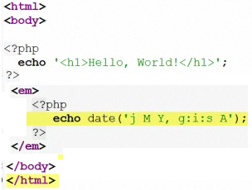

var_dump() function that outputs the type and value of a variable

$testInt = 100;

var_dump($testInt); output: int(100)

Escape sequence

* Single quote = \’
* Double quote = \”
* Backslash = \\
* Dollar = \$
* Newline = \n
* Tab = \t
* Special = \xA9

<%

$days = 7;

echo “there are $days days in a week\n”;

echo “<br/>\n”;

%>

**INCLUDE / REQUIRE**

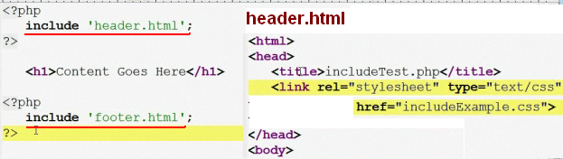

If a path is not specified, PHP will search in the location specified by the include_path in the php.ini file

